WINAIM Screening Assessment

First Task is that creating the table and the table name is employees including the columns name is employee id and first_name, last_name and department,hire date

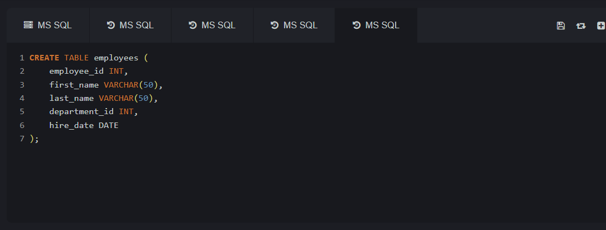

Second insert date into table

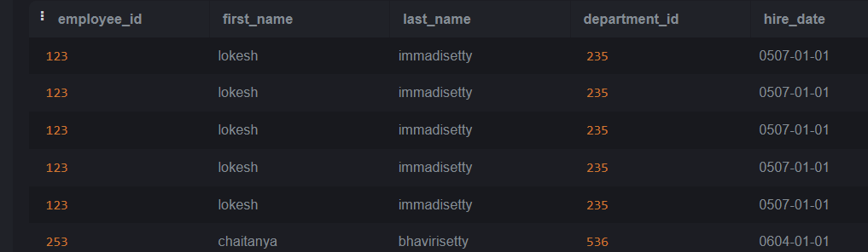

-- Creating the departments table

CREATE TABLE departments (

department_id INT PRIMARY KEY,

department_name VARCHAR(255) NOT NULL

);

-- Creating the employees table

CREATE TABLE employees (

employee_id INT PRIMARY KEY,

first_name VARCHAR(255) NOT NULL,

last_name VARCHAR(255) NOT NULL,

department_id INT,

hire_date DATE NOT NULL,

FOREIGN KEY (department_id) REFERENCES departments(department_id)

);

-- Creating the salaries table

CREATE TABLE salaries (

employee_id INT,

salary DECIMAL(10, 2) NOT NULL,

from_date DATE NOT NULL,

to_date DATE,

FOREIGN KEY (employee_id) REFERENCES employees(employee_id)

);